

Know Your TX – Dissecting a Transaction   
  
**Objective/Aim:**  
  
 To understand and analyze the structure of a blockchain transaction by viewing its details on a blockchain explorer.



**Apparatus/Software Used:**

* Laptop/PC
* MetaMask Wallet
* Blockchain Explorer (Etherscan for Sepolia testnet)
* Browser

**Theory/Concept:**

* **Transaction (TX):** A record of the transfer of value (ETH or tokens) or execution of a smart contract on the blockchain.
* **Blockchain Explorer:** A web tool to view detailed information about blockchain data including transactions, wallet balances, and block confirmations (e.g., Etherscan).



**Procedure:**

1.Open MetaMask click on the network selector at the top.

2.Select Sepolia Test Network.

3.Click on your MetaMask account name to copy your wallet address

4.Access Sepolia Faucet Website

5.Paste your copied MetaMask Sepolia address into the faucet input box.

6.Click on Request ETH

7.Wait for Transaction Confirmation

8. Open MetaMask, refresh, and see Sepolia ETH balance increased.

9.Click the transaction link from the faucet and check the details.

**Fig:- Transaction**

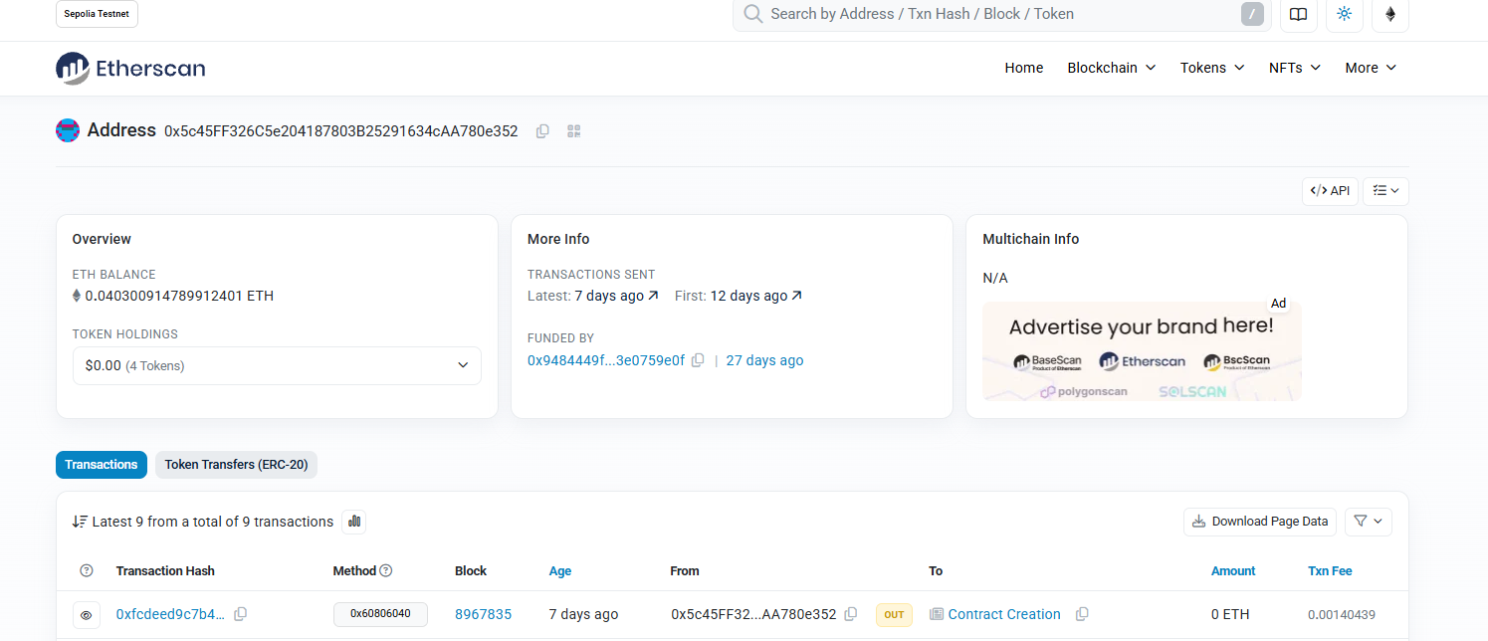

**Observation Table:-**

|  |  |
| --- | --- |
| **Sl no** | **Observation** |
| 1 | Wallet address copied and pasted on Sepolia Test Network. |
| 2 | ETH requested successfully from the faucet. |
| 3 | Sepolia ETH received in MetaMask wallet within minutes. |
| 4 | Transaction verified on Sepolia Etherscan with “Success” status. |

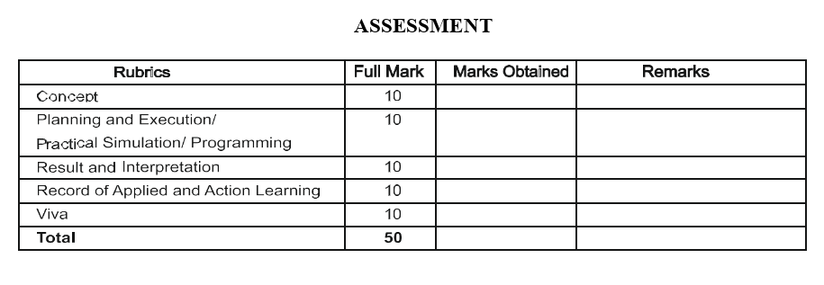

**Signature of the faculty: Signature of the Student:**

**Name:**

**Regn no:**